Document Information
Author | LynnetteM
Created Date | 22/06/2010
Last Updated By | LynnetteM
Date Updated | 27/10/2010
Developer
Project Manager | Simone Bresser / Gennine Inggs
Business Champion | Michele Bovet
SVN Location | svn://sahls31/SAHL/Project Documents 2016/IT Management/Processes and Standards/Reporting Standards.doc

Document History
Version | Author | Date | Detail of Changes
1.0 | Lynnette Moodley | 22/06/2010 | Created the Spec
1.1 | Lynnette Moodley | 08/10/2010 | Updated with new SAHL logo’s
1.2 | Lynnette Moodley | 27/10/2010 | Colour codes for web and presentations
1.3 | Mandy Stanton | 17/05/2016 | Added function for letter footer and updated letter logo url
1.4 | Mandy Stanton | 13/10/2016 | Reviewed report margin size
1.5 | Mandy Stanton | 14/02/2018 | Added content on creating a new report

Contents
1. Determining when an SQL Report is applicable 3
2. Creating a new report project 3
3. Creating a New Report 3
SubVersion 4
4. General Information for report or letter 5
4.1. Page Formatting 5
4.2. Data Formatting 5
4.3. Input Parameters 5
4.4. Font 6
4.5. Font Colour 6
4.6. Font Size 6
4.7. Report Logo 6
5. Report Information 8
5.1. Page Header 8
a) Column Header 8
b) Image Property 8
5.2. Page Footer 9
6. Letter Information 9
6.1. Letter Logo 10
6.3. Page Footer 10
7. Amending existing reports 11
8. Deployment 11
9. Location of Images for inclusion in reports/letters 12
9.1. HOC Company 12
9.2. Life Company 12
9.3. SAHL Company 12
9.4. RCS 12

Determining when an SQL Report is applicable

SQL reports should only be written for business or other external parties i.e. a client, an investor, an attorney or a valuer for the following reasons
No other report exists via HALO or batch reporting with the information required.
The data required is not available via any of the existing cubes.
The data that is required is going to be accessed frequently (at least once a month)
These SQL reports will need to be deployed to the various environments and tested prior to it being available in a production environment for the user.

Reports that are infrequent can be treated as data extracts; these will not require deployment to any environment. The code to extract the information can be run against SAHLS15 (day old data) or SAHLS03 (live data) depending on what type of information is required by the user.

Creating a new report project

Creating of a new report project is not advised unless absolutely necessary (Project Manager’s approval required).

Almost all new reports can be added to an existing report project; this will ensure that we comply with the reporting projects standards already established.

Creating a New Report
There are 2 methods to create a new report:
- Create a new report by right-clicking on “Reports” on the Solution Explorer menu.
  - Select “Add New Report”
  - When creating a new report, the data source to be selected will be dependant on whether the user requires real-time data (“Real-time”) or can accept data which is 24 hours old (“Reporting”).
  - Create your SQL query
  - Select your report layout
  - Select the fields required for your report
  - Select drill down options (if applicable)
  - Select your report style as ”Plain”
  - Give your report a meaningful name. Remember to prefix your report with the abbreviation for the applicable business area. See Appendix A.
- Create a new report by right-clicking on “Reports” on the Solution Explorer menu.
  - Select “Add” and then “Add New Item”
  - Enter a meaningful report name and click Open. Remember to prefix your report with the abbreviation for the applicable business area. See Appendix A.
  - Create a new dataset as below:
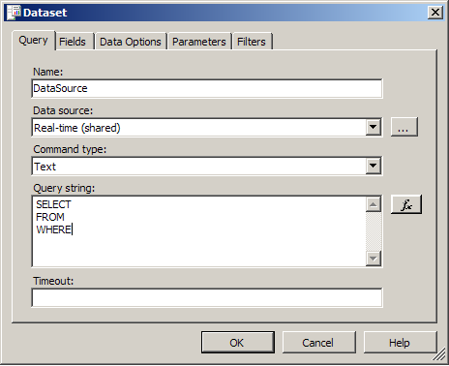
  - When creating a new report, the data source to be selected will be dependant on whether the user requires real-time data (“real-time”) or can accept data which is 24 hours old (“reporting”).
  - Create your SQL query
  - Create your report using the guidelines below

Report Presentation:

SubVersion
Once you have created your new report, it must be checked into subversion.

Please remember to check your reports in once you have received sign off and are ready to have the report deployed.

General Information for report or letter

Page Formatting
When creating a report or letter for the presentation the following formatting should apply:

- Portrait
Page Width : 21cm
Page Height : 29.7cm
Left margin : 2cm
Right Margin : 1.5cm
Top Margin : 1cm
Bottom Margin : 1cm

When setting the left and right margins as above bear in mind that the maximum allowable width of the page is 19 cm; so if this width is exceeded by even a millimeter, the report will print across 2 page widths.

- Landscape
Page Width : 29.7cm
Page Height : 21cm
Left margin : 2cm
Right Margin : 1.5cm
Top Margin : 1cm
Bottom Margin : 1cm

When setting the left and right margins as above bear in mind that the maximum allowable width of the page is 27.7 cm; so if this width is exceeded by even a millimeter, the report will print across 2 page widths.

Data Formatting
    - All currency fields must be formatted as currency (RXXX,XXX.XX)
    - All dates must be formatted as dd/mm/yyyy
    - All number fields which are not currency fields must be formatted as number XXX,XXX.XX
    - Loan Numbers, Client Numbers, Prospect Numbers, Telephone Numbers, Postal Codes etc should not be formatted as numbers.

Input Parameters
    - All dates input as input parameters must be in the format dd/mm/yyyy.
    - Input Parameters must be described in a meaningful way i.e. if you are expecting a date of 01/10/2005 do not call the input parameter Month End Date – Month Start Date is more meaningful.

Font
    - Always use the font “Arial”.

Font Colour
    - Report Header and Footer details – use “Dark Gray or Black” (for SAHL)
    - Report Header and Footer details – use “Dark Orange or Black” (for RCS)
    - Column Headers – use “Dark Gray” (for SAHL)
    - Column Headers – use “Dark Orange” (for RCS)
    - Field Data and general text – use “Black”. (Especially for letters)

For reference marketing have confirmed the following colour codes:
ORANGE:
CMYK – 0c 60m 100y 0k
RGB – 255r 102g 0b
PANTONE – 165c
WEB REF - #FF6600

GREY:
50K
CMYK - 0c 0m 0y 50k
RGB - 150r 150g 154b
Pantone – Cool Grey 7C
Web ref - #96969A

Font Size
    - Header – 14pt – 16pt Bold
    - Column Headers – 8pt – 12pt Bold
    - Data – 8pt –12pt

Report Logo
    - The report logo must not be embedded in the report; instead, you should link to the applicable logo using the URL as described in “Location of Images for inclusion in reports/letters” section of this document.
    - In order to link to an image, drag the image item from the toolbox onto the screen and complete. The details for the image source should be external so that the image can be accessed through a URL.
    - We have 3 versions of the logo:
- Centered – to be used in the middle of the page or when a clear alignment to one side is not possible. Use width 5cm, height 3.25cm

OR

- Left aligned – to be used in the top left or bottom left hand corner of the page. Use width 5cm, height 3.25cm


- Right aligned – to be used in the top right or bottom right corner of the page. Use width 5cm, height 3.25cm



Report Information

Page Header
The page header must contain, at a minimum, the SAHL Logo, Print Date, Print Time, Report Title, column headers and a dividing line as depicted below:

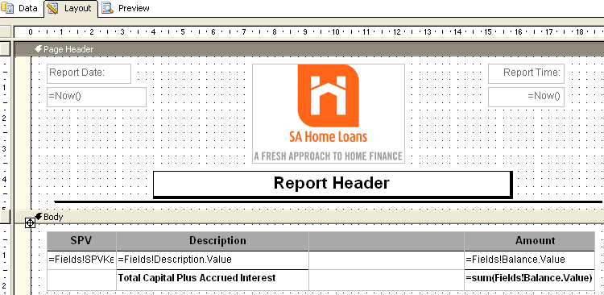

Column Header
If you are inserting your column headers in the Page Header portion of the page then the separating line should come below the column headers; alternately if you are inserting your column headers in the Body portion of the report then the line should appear below the report header block.

Image Property
Set the “Sizing” image property to FitProportional and the size to the dimensions described in “Location of Images for inclusion in reports/letters”.
The Sizing image property can be set under the properties tab for the selected image. (When using a SAHL Centered logo, use width 5cm and height 3.5cm)

Page Footer
The page footer must contain, at a minimum, the number of pages, the location of the file and a divider line as depicted below:

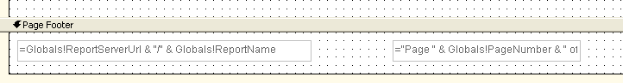
Where the location of the file can be determined using the following S2K Reports expression “=Globals!ReportServerUrl & "/" & Globals!ReportName“.

Letter Information
In instances where the requestor has indicated that the letter will be printed as well as faxed, an input parameter must be created with the option for “Fax\Print”.
If the “Fax” option is selected then the Letter Logo and Company Address subreport must be included on the report, under the details section, as follows:

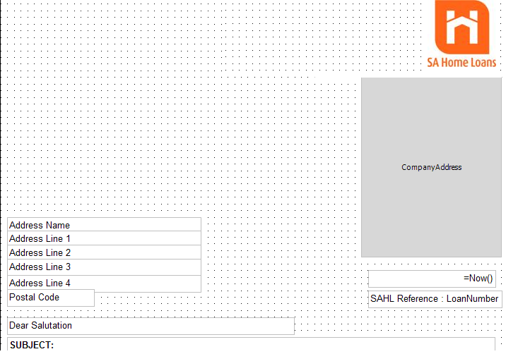

Letter Logo
The letter logo must not be embedded in the letter; instead, you should link to the applicable logo using the URL http://sahls15/images/SAHL/SAHL_Letter_logo.jpg
For testing use: http://UAT2-15/images/SAHL/SAHL_Letter_logo.jpg

Use Autosize or width 3cm, height 2.8cm

  - Company Address
The Company Address sub report is a standard report called Com.Company Address.rdl, which exists in each of the report folders. The sub-report control should be inserted and right aligned with the right-hand side of the company logo. The sub report should have the following sizes:

Company | Width | Height
SA Home Loans | 5.4cm | 6.2cm
SAHL Life | 4.75cm | 4.25cm
SAHL Insurance Company | 5.25cm | 5.5cm

Page Footer
- The report footer should display the directors for each company as well as the company registration details.
- The director’s details are extracted from the database.
- The director’s as well as the company details are extracted and displayed differently in the letters for each company. A sql code needs to be apart of the letter’s dataset in order to return the relevant information.
Example of sql : SELECT * FROM [2am].dbo.fGetLetterFooterSlim (1)
- The Directors will be displayed ONLY on the first page.

Eg.
Directors: Executive KL Penwarden, C Swainston Harrison
Non-Executive: L McCarthy, K Makeke, K S Maponya, R Rajdhar, W M Masekesa (Zimbabwe), B P Madungandaba, M R Bantsi (Alternate to B P Madungandaba), N Mazibuko (Alternate to K S Maponya); Company Secretary: U L Schei.
SA Home Loans (Pty) Ltd is a Registered Credit Provider (Registration Number: NCRCP1735)

Amending existing reports
When amending existing reports, please make the changes as requested by the report owner but also check that the report complies with the guidelines laid out above.

Deployment
Whilst the report is being developed and tested by yourself or the report owner, check the report into the svn://sahls31/SAHL/Reports/Dev folder in subversion and then make the relevant notes in the trac ticket for the report to be deployed to the different environments and is accessible in HALO for testing.

Once the report has been UAT tested and signed off by the business user, request that the report be deployed to the production environment.

Please remember to include any other relevant instructions; example: if you have amended the name of the report, advise the DBA’s to delete the existing report and replace with the new report.

Location of Images for inclusion in reports/letters
All the images that should be used in the various reports are available on SAHLS15 in a central location, by Company.

HOC Company
The various images are located at:
Letterhead Logo - http://sahls15/images/HOC/LetterLogo.jpg - Dimension: 5.5cm, 2.75cm
Director’s Signature (Tim Bean) - http://sahls15/images/HOC/MDSig.jpg - Dimension: 1.5cm, 3cm

Life Company
The various images are located at:
Letterhead Logo - http://sahls15/images/LIFE/LetterLogo.jpg - Dimensions: 6cm, 3.5cm
Director’s Signature (Tim Bean) - http://sahls15/images/LIFE/MDSig.jpg - Dimension: 1.5cm, 3cm

SAHL Company
There are various SAHL images used for reports, each of them have the payoff line included. The only differences between them are the alignment. The logo’s are in the following locations:
http://sahls15/images/SAHL/ReportLogo.jpg
http://sahls15/images/SAHL/ReportLogo_Centered.jpg
http://sahls15/images/SAHL/ReportLogo_Left.jpg

For testing:
http://uat1-15/images/SAHL/ReportLogo.jpg
http://uat1-15/images/SAHL/ReportLogo_Centered.jpg
http://uat1-15/images/SAHL/ReportLogo_Left.jpg

The following SAHL logo, without the payoff line should be used for letters. The image can be located at:
http://sahls15/images/SAHL/SAHLLetterlogo.jpg

TEST: http://sysc15/images/SAHL/ReportLogo_Centered.jpg

RCS
The various images are located at:
http://sahls15/images/RCS/letterlogo.jpg

More Signatures: (saved here: \\sahls15\images$\SAHL)

http://sahls15/images/HOC/Colin_Young_Sig.jpg

